**ASCII Console Game Challenge**

Challenge:

Make the best game you can in a (windows) console! This could be Snake, Pong, Space Invaders, all kinds of classics (with varying difficulties). This can be achieved using a bunch of Windows API commands e.g. moving cursor. As such, you will need to use MSDN for documentation in this challenge, a very useful skill to learn. You should use the skeleton program provided to get started!

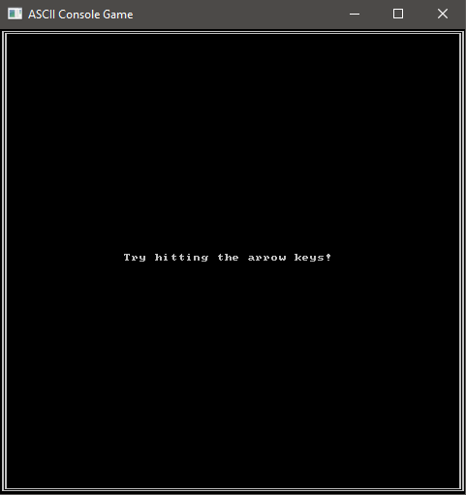

Extensions:

* Make your game use multiple colours. Hint: I’ve intentionally not provided the sample code for this in the skeleton program, you should try to find this yourself!
* Allow the player to select their desired difficulty
* Add a pause feature, everyone likes to be able to take breaks every now and then